

Cloud4SOA General Assembly
9-10 December 2010
Athens
Project acronym: Cloud4SOA
Project full title: Cloud Interoperability Framework and Platform for User-Centric, Semantically-Enhanced Service-Oriented Applications Design, Deployment and Distributed Execution
Grant agreement no.: 257953

Agenda: Cloud4SOA general assembly

Subject: | Official kick-off meeting: Day 1

Location: | Athens | Time: | 13:00 – 18:30 | Date: | 9 December 2010
 | SingularLogic premises

Subject: | Official kick-off meeting: Day 2

Location: | Athens | Time: | 09:00 – 13:00 | Date: | 10 December 2010
 | SingularLogic premises

Objectives
The meeting is the first official general assembly of Cloud4SOA project
- Ensure a smooth start of the WP8, and a first check point of the WP1 and 9
- Assign clear responsibilities for the Tasks of the Work Packages and the Deliverables to submit
- Overview of the detailed plan for the first Phase of the project (Work Package 1) and deviations
- Broaden the technical understanding of the project and the base technologies

Participants:
- All project partners

Expected Results
- Project partners form a good working relationship
- Responsibilities for the deliverables of the first phase are assigned
- The roles of each partner in the WPs are assigned.
- An immediate start of the project is achieved.

Preparation and Background Reading
- It is expected that all participants are familiar with all the tasks active so far.

Venue
The meeting will be held in:

SingularLogic premises
Al. Panagouli & Siniosoglou str. N. Ionia-Attica, Metro Station: N. Ionia (Line 1)

Contact persons:

Stelios Pantelopoulos
Tel: +30 210 62 66 260
Fax: +30 210 62 66 643
Mob.: +30 6974024424
Email: spantelopoulos@singularlogic.eu

Evelina Peristeri
Tel: +30 210 62 66 262
Email: eperisteri@singularlogic.eu

When:

December 9: 13:00 – 19:00
December 10: 09:00 – 14:00

Social Event:

Guide to the colours in the agenda

Plenary - Room C-310 | Social Event | Break
DAY 1 – December 9, 2010 13:00 – 19:00
13:00 – 13:20  (20 min) | Welcome and meeting overview.  - Welcome  - Overview of agenda and objectives for the meeting | Francesco D’Andria  ATOS ORIGIN
13:20 – 14:20  (60 min) | WP1 Cloud4SOA Reference Framework  - Detailed overview of the WP1 roadmap  - Actual status and high level overview of the next steps  - D1.1 TOC (preferably with assigned responsibility, reviews and internal roadmap) | Nikos Loutas  CERTH
14:20 – 16:00  (100 min) | Open discussion on the Requirements definition and Reference Architecture | Nikos Loutas  CERTH  All
16:00 – 16:30  (30 min) | COFFEE BREAK
16:30 – 17:00  (30 min) | Open discussion on Scenario definition from the Business View perspective. | James Ahtes  ATOS ORIGIN leads  the round table
17:00 – 17:45  (45 min) | Official WP8 Kick-off:  Showcases Development and Overall Performance Evaluation  - WP8 roadmap (a detailed roadmap for the first 6 M of the WP is needed)  - Use cases and Showcase Definition (could be nice have a first description of the three scenarios) | Wolfgang Prinz  FIT  Singular Logic  (technical support)
17:45 – 18:30  (45 min) | Cloud4SOA (WP2, WP3, WP4) – WP Technical Overview (15 min each)  (A high level overview should be showed for each technical layer, highlighting general needs, issues, possible solution. If apply project to collaborate with) | DERI,  CYNTELIX  DERI
18:30 | CLOSURE OF THE FIRST DAY
DAY 2 – September 10, 2010 09:00 – 13:00
9:15 – 9:30 | Welcome and second day overview. | Francesco D’Andria ATOS Origin
9:30 – 10:00  (30 min) | Cloud4SOA (WP5 and WP6) - WP Technical Overview (15 min each)  (A high level overview should be showed for each technical layer, highlighting general needs, issues, possible solution. If apply project to collaborate with) | ATOS  SINGULAR LOGIC
10:00 –10:10  (10 min) | WP9 Overview  - WP9 Roadmap (include all the tasks)  - WP9 effort breakdown | James Ahtes  ATOS ORIGIN
10:10 –10:30  (20 min) | Exploitation Activities  - Market Analysis progress  - D9.3.1 TOC (preferably with assigned responsibility)  - Resume of the first day discussion. | James Ahtes  ATOS ORIGIN
10:30 –11:00  (30 min) | Collaboration & Standardization Activities  - Collaboration and Standardization plan & Matrix  - D9.4.1 TOC (deadline M6)  - Overview of the project we are going to collaborate with | Giovanni Tummarello  DERI  James Ahtes  ATOS ORIGIN
11:00 – 11:20 | COFFEE BREAK
11:20 –11:50  (30 min) | Open Discussion on the task 9.5: Cloud Interoperability Special Interest Group:  - Initial list of members  - Requirements questionnaire and other feedback activities  - Plan (next steps + future involvement) | Wolfgang Prinz  FIT  and  Nikos Loutas  CERTH
11:50 –12:10  (20 min) | Dissemination Activities  - Initial Communication Plan (presentation)  - Official Project web site (first version by month 4)  - Events and conferences | Wolfgang Prinz  FIT
12:10 – 12:30  (20 min) | WP10: Consortium and Project Management  - ID10.1 Quality plan (TBD if there is time) | SingularLogic  Francesco D’Andria ATOS Origin
12:30 – 13:00  (30 min) | General Assembly Conclusions and Next Steps | Francesco D’Andria ATOS Origin
13:00 | CLOSURE OF KICKOFF

Participation list:

Organization | Name
ATOS | Francesco | D'Andria
ATOS | James | Ahtes
DERI
DERI
CERTH
SingularLogic
SingularLogic
SingularLogic
CloudControl
CloudControl
Cyntelix
Cyntelix
Cyntelix
Portugal Telecom
Fraunhofer FIT
RomTelecom

Cloud4SOA Meeting

Athens 9-10 December 2010

Place: SingularLogic premises
Al. Panagouli & Siniosoglou str. N. Ionia-Attica, Metro Station: N. Ionia (Line 1)

Useful Information

Meeting Place
The meeting will be held at SingularLogic premises. The offices are in near the Metro Station N. Ionia (Line 1). Walking distance ~ 10 min.
The entrance is at the opposite site of a BP gas station. In general, you can estimate about 45-60 minutes to get from the centre to SingularLogic.
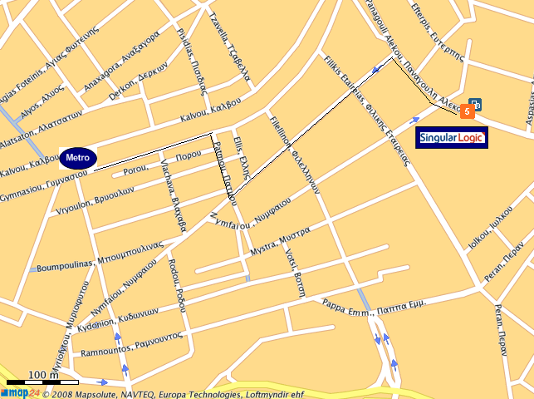

- When you get off the train (towards Kifisia) in N. Ionia Station, go straight on the left and in parallel with the lines.
- You turn right either in Patmou str. Or Fillelinon.
- Left in Nymfaiou str.
- Once you find Al. Panagouli turn right and the entrance of SingularLogic
Hotels-Accommodation
Unfortunately there are no hotels near SingularLogic, neither any specific arrangements with the company. Some (indicative) hotels in the centre and near the metro are the following:

STANLEY HOTEL CATEGORY A
(Metro station: Metaxourgeio)
Tel: +30 210 5241611
www.gtp.gr/stanleyhotel

PRESIDENT HOTEL CATEGORY A
(Metro station: Alexandras or Panormou)
Tel: +30 210 6989500
www.president.gr

PARK HOTEL CATEGORY DELUXE
(Metro station: Victoria)
Tel: +30 210 8894500
www.parkhotel.gr

MAGNA GRECIA BOUTIQUE HOTEL
(Metro station: Syntagma or Monastiraki)
Tel: +30 210 3240314-5
www.magnagreciahotel.com

RESIDENCE GEORGIO CATEGORY DELUXE
(Metro station: Omonoia)
Tel: +30 210 3320100
www.residencegeorgio.com

How to get from your hotel to the meeting place (SingularLogic)
- Take the Metro Line 1 towards Kifisia.
- You will stop at the N. Ionia Station.
- In front of the station (from the side you will get off) you follow the small provided map at page 1.
- After 5-10 minutes walking you will find the Siniosoglou and Al. Panagouli corner. The SingularLogic main entrance is at the opposite site of a BP gas station
You can also use taxi but it is not recommended for working days due to the long traffic (and of course cost…☺).

How to get from the Airport to the hotel or the meeting place
When you will arrive at Athens Airport there are 3 ways to move from there:
- Suburban Railway & Metro line: In such case you will need about 1 hour to get to the hotel. Looking at the metro map you will easily identify which lines to take for your final destination.
- Taxi: More expensive but maybe you will get to the centre faster if you arrive on Sunday. Not recommended for getting from the Airport to the centre in working days!!!
- Buses & Metro Line: There are busses going go the Ethniki Amyna Station from where you can take the metro lines (see below map; also can be found at http://www.amadeus.net/home/new/subwaymaps/en/athens.htm)
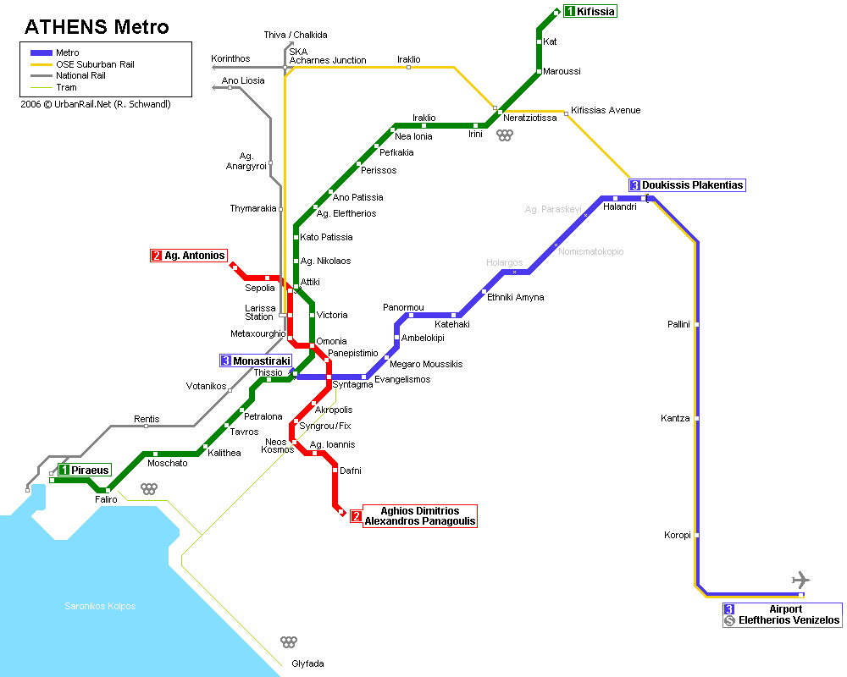
Contact Persons:
For any further information you may contact the following persons:

Stelios Pantelopoulos
Tel: +30 210 62 66 260
Fax: +30 210 62 66 643
Mob.: +30 6974024424
Email: spantelopoulos@singularlogic.eu

Evelina Peristeri
Tel: +30 210 62 66 262
Email: eperisteri@singularlogic.eu

